Sheet List
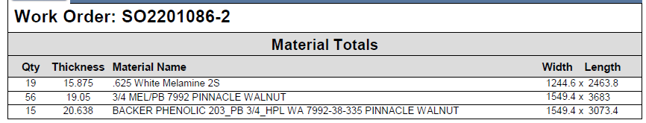

Edgeband List
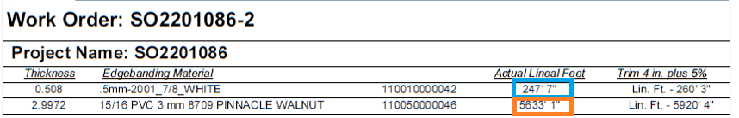
Edgebanding calculations:
For “.5mm-2001_7/8_WHITE”:
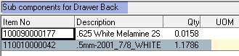
Total quantity per parent:
Qty = 1.1786
Qty for all 210 units: 1.1786 * 210 = 247.506 (This is approximately the value shown on the report above for the “.5mm-2001_7/8_WHITE”: component: 247’ 7’’)
For “15/16 PVC 3 mm 8709 PINNACLE WALNUT”:
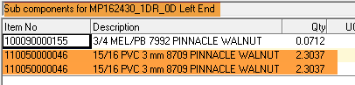
Total quantity per parent:
Qty = 2.3037 * 2 = 4.6074 LFT
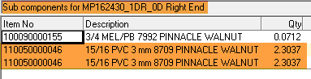
Total quantity per parent:
Qty = 2.3037 * 2 = 4.6074 LFT
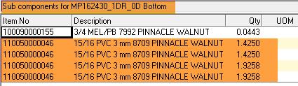
Total quantity per parent:
Qty = 1.4250 * 2 = 2.85 LFT
Qty = 1.9258 * 2 = 3.8516 LFT
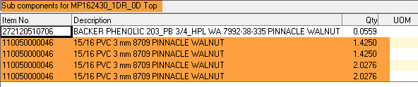
Total quantity per parent:
Qty = 1.4250 * 2 = 2.85 LFT
Qty = 2.0276 * 2 = 4.0552 LFT
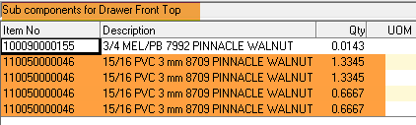
Total quantity per parent:
Qty = 1.3345 * 2 = 2.669 LFT
Qty = 0.6667 * 2 = 1.3334 LFT
Total Qty (Sum of all quantities in light-brick colour for this component): 26.824 LFT
Total Qty for all 210 units: 26.824 * 210 = 5633.04 (This is approximately the value shown on the report above for the “15/16 PVC 3 mm 8709 PINNACLE WALNUT” component: 5633’ 1’’)

BOM Parts

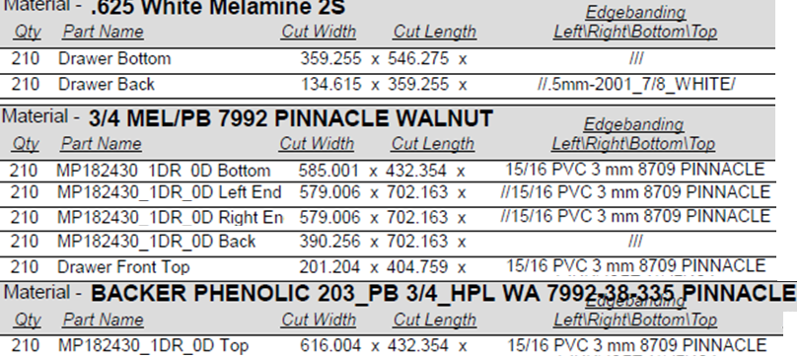
Material calculations:
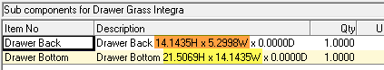
Converting inches to mm:

Drawer Back
Adjusted Width: 5.2998 (It seems that MV uses this value in the calculations. This is probably including trimming.)
5.2998 * 25.4 = 134.61492 mm (approximately matches the 134.615 from the above report)
See next picture showing the difference between the width values:
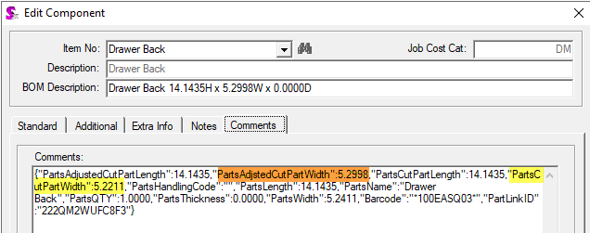
Adjusted Length: 14.1435 * 25.4 = 359.245 mm (approximately matches the 359.255 from the above report)
Drawer Bottom
Adjusted Width: 14.1435 * 25.4 = 359.245 mm (approximately matches the 359.255 from the above report)
Adjusted Length: 21.5069 * 25.4 = 546.2753 mm (approximately matches the 546.275 from the above report)

Here showing the material for the “MP162430_1DR_0D Bottom” component to be able to show the quantity per parent calculation as well:
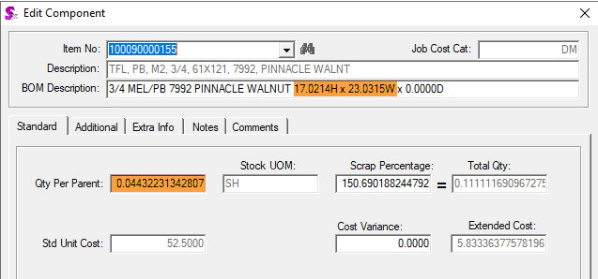
Adjusted Width: 23.0315 * 25.4 = 585.0001 mm (approximately matches the 585.001 from the above report)
Adjusted Length: 17.0214 * 25.4 = 432.3436 mm (approximately matches the 432.354 from the above report)
Note that the non-adjusted dimensions are smaller: Width: 22.8741 and Length: 16.8640
It looks like MV always uses the adjusted values in the calculations, so the BOM description was modified to show them as in the above picture.

Quantity per Parent calculation:
Area: Width * Length = 585.001 * 432.354 = 252,927.5224 sq mm (note that the optimization logic uses the adjusted width and length as well)
Sheet area: 61 * 145 = 8,845 sq in = 5,706,440.2 sq mm (note that this sheet size is the one used by the optimization in this particular case and it is stored in the PlacedSheets table)
Qty Per Parent: 252,927.5224/5,706,440.2 = 0.044322 SH (this value is approximately the same as the nominal Qty Per Parent shown in the above picture)
Note that the other components can be calculated and matched the same way.

